Draft 1 (training graph plottingnya enak, tapi conf matrix disandingkan 3)

4.2 Evaluasi dan Pengujian

[yapping]

4.2.1 Hasil Pengujian Model tanpa penyesuaian beban pada kelas

Res 18

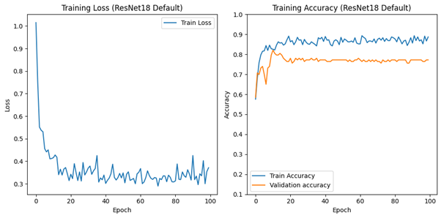

Training graph

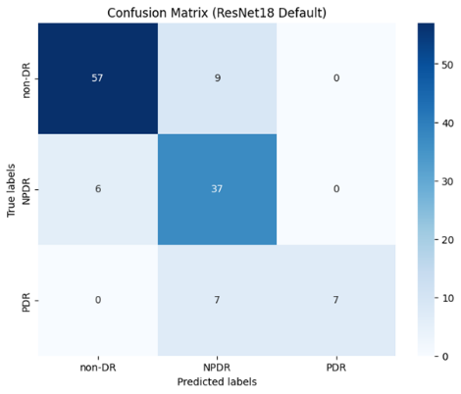 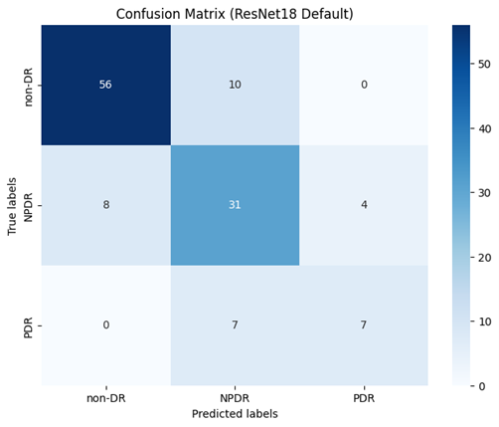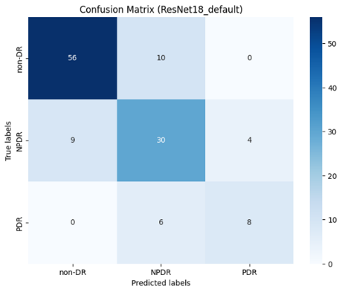

Confusion matrix model training, validation, dan last model

Res 34

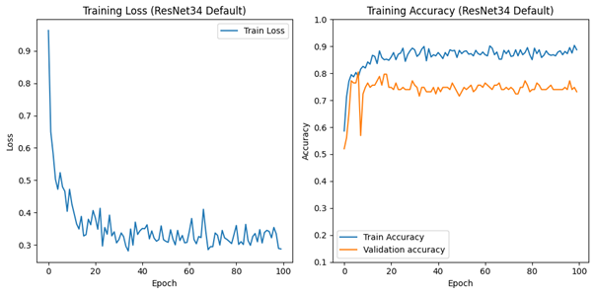

Training graph

Confusion matrix model training, validation, dan last model

4.2.2 Hasil Pengujian Model dengan menggunakan penyesuaian beban kelas

Res 18

Training graph

Confusion matrix model training, validation, dan last model

Res 34

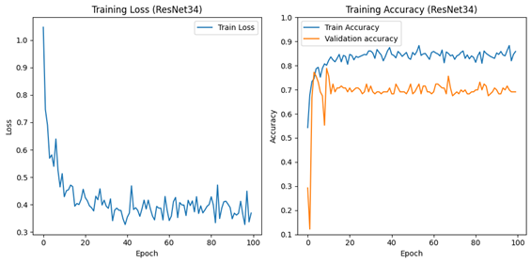

Training graph

Confusion matrix model training, validation, dan last model